

The Impact of AI-Driven Customer Service Tools on Modern Retail Management

Student Name: Desala Likhitha Mahalaxmi
Student ID: A9920124022429(el)
Course Name: MBA IT Management
Date: 6th Dec 2025

S. No. | Section | Page No.
1 | Abstract | 1
2 | Introduction of the Study | 2
3 | Objectives of the Study | 3
4 | Literature Review / Background Study | 4-6
5 | Research Methodology | 7
5.1 | Research Design | 7
5.2 | Data Collection Method | 7
5.3 | Scope of the Study | 7
5.4 | Limitations of the Study | 7
6 | Data Analysis and Interpretation | 8-9
7 | Results and Discussions | 10-13
8 | Recommendations and Conclusion | 14
8.1 | Recommendations | 14
8.2 | Conclusion | 14
9 | Bibliography & References | 15

1. ABSTRACT
This project explores the growing impact of Artificial Intelligence (AI)–driven customer service tools on modern retail management. As retail organizations transition toward digital-first operations, AI technologies such as chatbots, voice assistants, recommendation engines, automated query-handling systems, and sentiment-analysis tools have transformed the way retailers interact with customers. The study examines how AI enhances operational efficiency, improves customer satisfaction, reduces service response time, and assists in personalized retail experiences. Using secondary research drawn from industry reports, articles, retail case studies, and academic literature, this project highlights the opportunities, challenges, and emerging trends associated with the adoption of AI in retail customer service. The findings show that AI not only improves customer engagement but also supports managerial decision-making, supply chain accuracy, and long-term customer loyalty. Recommendations are provided for retailers to responsibly integrate AI tools while maintaining human touch and service quality.

2. INTRODUCTION OF THE STUDY
The retail industry has transformed rapidly due to technological advancements, rising customer expectations, and the shift toward customer-centric strategies. Modern consumers expect fast responses, personalized recommendations, and seamless experiences across online and offline channels. To meet these demands, retailers are increasingly using AI technologies such as chatbots, virtual assistants, predictive analytics, recommendation engines, and self-service kiosks. These tools are redefining customer engagement, improving operational efficiency, and supporting smarter decision-making.
AI-Driven Customer Insights in Retail
AI-driven insights help retailers extract meaningful patterns from digital and in-store data such as clicks, browsing behavior, social media activity, purchases, reviews, and footfall. By analyzing this information, AI predicts preferences, buying likelihood, and behavior trends. These insights guide marketing, product development, and service strategies, helping retailers understand what customers value and how to build loyalty through more personalized experiences.
Personalized Marketing
AI enables personalized marketing by analyzing large datasets to create precise customer segments based on behavior, history, and preferences. This improves targeting, engagement, and decision-making. AI also supports dynamic pricing by adjusting prices for different sensitivity levels, leading to higher sales frequency, more consistent revenue, and more effective, relevant advertising.
Inventory Management
AI improves inventory management by accurately forecasting demand using machine learning and predictive analytics. It considers promotions, pricing, seasonality, and external factors to reveal hidden patterns and maintain optimal stock levels. Deep learning models can also simulate stockout scenarios, reducing lost sales and ensuring timely product availability.
Impact of AI on Retail Customer Service
AI transforms customer service by automating routine tasks and offering instant, personalized support. Chatbots, virtual assistants, and NLP tools provide 24/7 assistance and handle large query volumes efficiently. Predictive analytics enhances omnichannel experiences by anticipating customer needs. A practical example is Samsung Spain’s AI-powered queue and appointment system, which reduced wait times and improved satisfaction.
The Role of AI in Modern Retail
AI technologies—machine learning, NLP, and advanced analytics—enable smarter decisions across marketing, pricing, product design, inventory, and customer service. AI has become essential for competitiveness, helping retailers optimize operations, improve personalization, and deliver superior experiences. As AI continues to advance, its ability to predict needs, streamline processes, and drive business growth will only expand.

3. OBJECTIVES OF THE STUDY
The primary purpose of this study is to explore the transformative role of Artificial Intelligence (AI) in modern retail, particularly in enhancing customer service, optimizing operations, and supporting managerial decision-making. With the rapid adoption of digital technologies, retailers increasingly use AI-driven tools to meet evolving consumer expectations and create seamless shopping experiences. This research focuses on understanding effective AI integration in retail and its implications for businesses, employees, and customers.
A key objective is to examine the role of AI-driven customer service tools, such as chatbots, virtual assistants, self-service kiosks, and predictive analytics systems, in managing customer interactions, automating routine tasks, and providing real-time support. By analyzing these applications, the study highlights how AI streamlines operations, reduces manual workload, and improves service delivery, helping retailers remain competitive in dynamic markets.
Another objective is to assess how AI enhances customer experience and service efficiency. AI analytics enable retailers to understand customer behavior, anticipate needs, and provide personalized, timely interactions. The study evaluates AI’s role in reducing wait times, ensuring consistent service, creating loyalty, and improving operational efficiency through better resource management and workflow optimization.
The research also examines challenges in implementing AI, including high costs, employee or customer resistance, integration issues, data privacy concerns, and the need for ongoing training. Understanding these barriers helps develop strategies for effective AI adoption.
Additionally, the study evaluates AI’s impact on managerial decision-making. AI-powered analytics and predictive models provide real-time insights into sales trends, customer behavior, and operational performance, supporting evidence-based decisions in marketing, inventory management, staffing, and customer engagement.
Finally, the study aims to provide actionable recommendations for integrating AI tools in customer service and operations, focusing on maximizing satisfaction, efficiency, scalability, and alignment with organizational goals and best practices.
In summary, this research offers a comprehensive understanding of AI in retail, highlighting its benefits, challenges, and strategic applications for improving customer experience, operational efficiency, and business performance.

4. LITERATURE REVIEW / BACKGROUND STUDY
Artificial Intelligence (AI) is transforming retail by improving efficiency, customer engagement, and decision-making. Leading retailers like Amazon, Sephora, IKEA, Flipkart, and Walmart use AI tools—chatbots, virtual assistants, and recommendation engines—to automate routine tasks, reduce wait times, and manage large-scale interactions.
Chatbots and virtual assistants handle 70–80% of queries, offering instant responses, order tracking, and 24/7 support. AI recommendation engines analyze customer behavior to deliver personalized suggestions, boosting satisfaction and driving up to 40% revenue growth.
Predictive analytics helps managers forecast demand, optimize inventory, monitor sentiment, and assess employee performance—preventing stockouts or overstocking. AI also streamlines supply chains with real-time tracking, route optimization, and waste reduction, enhancing availability, lowering costs, and improving customer satisfaction.

Benefits of AI in Retail Customer Service
AI offers several advantages for retailers. It provides deeper customer insights by analyzing behavior and preferences, enabling targeted marketing, personalized offers, and stronger loyalty. AI also delivers personalized shopping experiences through tailored product recommendations, boosting engagement, satisfaction, and repeat purchases. Predictive analytics improve demand forecasting, helping retailers optimize inventory and reduce waste. Automated customer support via chatbots and virtual assistants handles routine queries quickly, freeing human staff for complex issues. Additionally, AI enhances supply chain efficiency through timely restocking, route optimization, and real-time visibility. Overall, AI gives retailers a competitive edge by enabling more personalized, efficient, and seamless customer experiences.

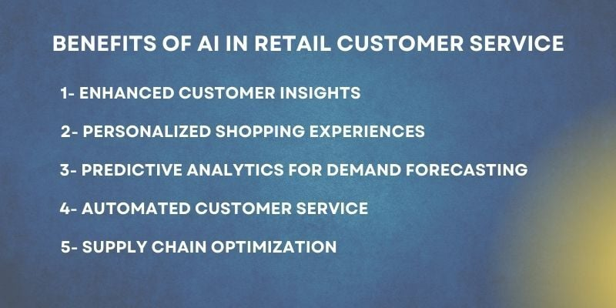

Benefits for Businesses and Customers
AI Application | Benefit for Businesses | Benefit for Customers
AI Chatbots & Virtual Assistants | Reduces support costs by 30%. | Instant 24/7 support & faster issue resolution.
Predictive Analytics for Demand Forecasting | Cuts inventory costs & minimizes waste. | Ensures product availability & prevents disappointment.
Personalized Marketing Campaigns | Boosts conversion rates by 35%. | Customers receive relevant deals & promotions.
Automated Checkout (AI-Powered POS) | Speeds up transactions & reduces wait times. | Frictionless, faster checkout experience.
Fraud Detection & AI Security | Prevents fraud & financial loss. | Ensures secure, safe transactions.

Challenges and Considerations
Despite its benefits, AI adoption in retail presents challenges. Excessive automation can reduce the personal touch, leaving customers feeling disconnected, so a balance between AI and human support is essential, especially for complex or emotional issues. AI also raises ethical concerns, as it relies on large amounts of customer data, creating risks around privacy, security, and algorithmic bias. Regulations like GDPR and CCPA require responsible data use, and retailers must ensure fairness, transparency, and inclusivity to maintain trust. Addressing these challenges is crucial for effective AI integration while preserving customer satisfaction and ethical standards.

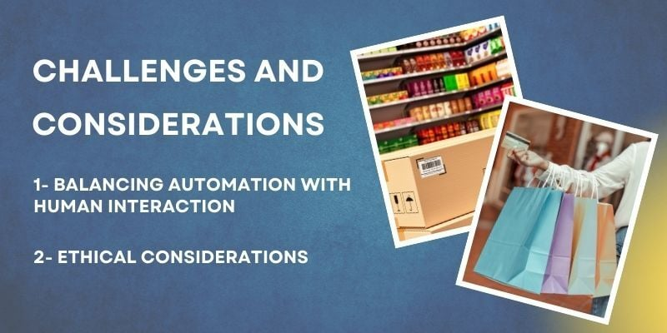

Future Trends in AI for Retail Customer Service
AI in retail is evolving along two key trends. Omnichannel integration enables seamless experiences across online, in-store, and mobile channels, with businesses adopting strong strategies retaining up to 89% of customers. Advances in AI technology are also driving personalization and convenience, often integrating with AR and voice assistants, as seen in IKEA’s “IKEA Place” app and Amazon’s Alexa, enhancing customer engagement and immersive shopping experiences.
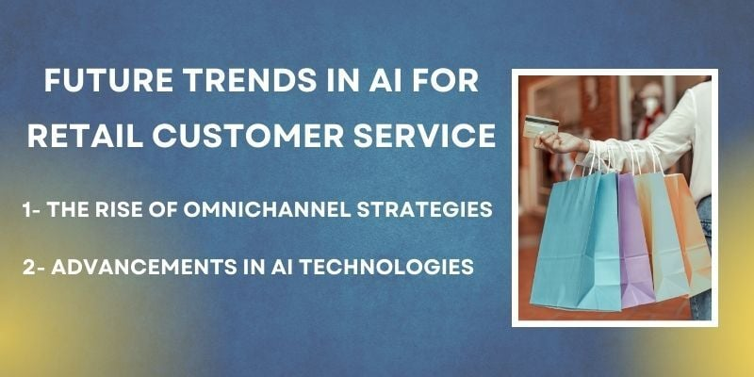

Implications of AI-Driven Customer Insights
AI and big data help retailers analyze behavior, predict needs, and streamline operations. With real-time insights, companies can enhance branding and product design, improve marketing and personalization, and strengthen customer loyalty. Retailers that use AI-driven insights effectively gain a clear competitive edge through data-driven innovation, greater efficiency, and better customer experiences.

5. RESEARCH METHODOLOGY
5.1 Research Design
This study uses an exploratory and descriptive research design to examine the role of Artificial Intelligence (AI) in retail customer service. The exploratory component helps identify emerging trends and technologies, while the descriptive aspect provides a structured analysis of how AI influences retail operations. As required by the project, the study relies entirely on secondary data, enabling a broad review of existing literature, industry practices, and research findings. This approach helps identify key patterns, benefits, challenges, and future directions for AI adoption in retail.
5.2 Data Collection Method
The study is based on secondary data gathered from credible and diverse sources, including:
- Trade Journals: Retail Week, Harvard Business Review, and similar publications.
- Academic Papers: Peer-reviewed journals and conference articles on AI in retail.
- Industry Reports: Insights from Deloitte, McKinsey, KPMG, Gartner, and others.
- Online Case Studies: Examples from Amazon, Sephora, IKEA, and other retailers.
- Company Websites: Details on AI strategies and customer service initiatives.
- Multimedia Sources: YouTube interviews, documentaries, and webinars.
- News and E-commerce Articles: Current developments, challenges, and success stories.
This multi-source method ensures a comprehensive understanding that integrates theory with real-world applications.
5.3 Scope of the Study
The study examines AI’s impact on retail customer service, focusing on key tools such as chatbots, virtual assistants, recommendation engines, predictive analytics, and automation. It explores how AI enhances efficiency, supports managerial decisions, and shapes retail management practices. The study also assesses AI’s effects on customer satisfaction, personalization, inventory and supply chain management, and overall performance, while considering its benefits, challenges, and role in creating a competitive advantage.
5.4 Limitations
The study acknowledges the following limitations:
- No Primary Data: Lack of surveys or interviews limits firsthand perspectives.
- Dependence on Secondary Sources: Findings rely on the accuracy and depth of existing materials.
- Fast-Evolving Technology: AI trends may become outdated quickly.
- Context-Specific Insights: Case studies from select markets may not apply universally.
6. DATA ANALYSIS & INTERPRETATION
Trend 1: Rapid Adoption of AI Chatbots
- Observation: Over 60% of retail companies use AI chatbots for customer inquiries, reducing costs and response times.
- Interpretation: AI handles routine queries, freeing human staff for complex issues.
- Supporting Statistic: 80% of customer interactions will be AI-handled by 2025.
Trend 2: Personalization Drives Customer Loyalty
- Observation: Personalized recommendations increase purchase likelihood.
- Interpretation: AI-driven personalization boosts engagement and revenue.
- Supporting Statistic: 91% of consumers prefer brands offering personalized experiences.
Trend 3: AI Improves Inventory and Demand Forecasting
- Observation: AI enhances demand prediction accuracy.
- Interpretation: Managers optimize stock, reduce waste, and improve supply chain efficiency.
- Supporting Statistic: AI reduces stockouts by 30–50%.
Trend 4: Cost Efficiency in Customer Support
- Observation: AI cuts customer service costs by 30–40%.
- Interpretation: Makes AI a cost-effective choice for large-scale retail operations.
Trend 5: Customer Acceptance of AI
- Observation: Customers appreciate speed and automation but still prefer humans for complex issues.
- Interpretation: Retailers should balance AI for routine tasks with human support for nuanced cases.

AI Technologies and Their Impact on Retail

AI Technology | Impact on Retail | Supporting Statistic
Chatbots & Virtual Assistants | Provides 24/7 customer support & reduces response times. | 80% of customer interactions will be handled by AI by 2025.
AI-Powered Personalization | Recommends tailored products based on customer behavior. | 91% of consumers are more likely to shop with brands offering personalized experiences.
Visual Search & Image Recognition | Enables customers to find products via images instead of text. | Retailers using visual search see a 30% higher conversion rate.
AI-Driven Inventory Management | Predicts demand & prevents stockouts. | AI reduces stockouts by 30-50%, improving customer satisfaction.
Voice Commerce (AI Assistants) | Enables hands-free shopping via smart speakers. | 71% of consumers prefer voice search over typing for shopping.

7. RESULTS & DISCUSSIONS
7.1 Key Findings
The analysis of secondary data and case studies highlights the following key findings regarding AI adoption in retail:
- Enhanced Customer Experience: AI improves customer experience through faster response times, personalized services, and 24/7 availability.
- Retail Management Benefits: AI tools enable better forecasting, customer behavior analysis, and informed managerial decision-making.
- Operational Efficiency: Automation of routine tasks reduces human workload, cuts costs, and streamlines operations.
- Customer Insights: AI provides valuable insights, allowing managers to tailor business strategies to meet market demands.
- Challenges: Implementation challenges include data security concerns, high technology adoption costs, and resistance from employees hesitant to embrace automation.

7.2 Key Technologies and Applications of AI in Retail
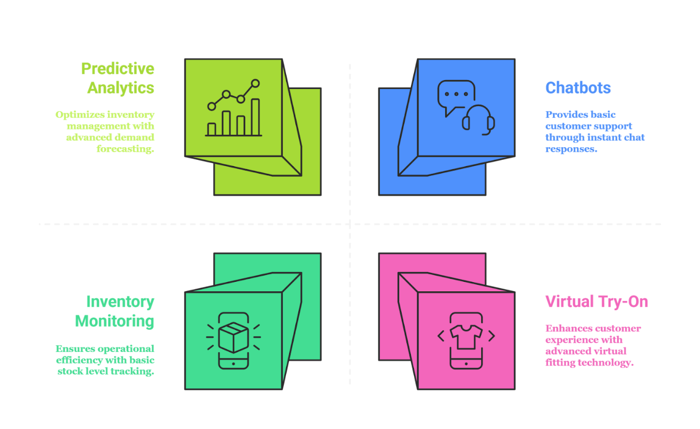
Machine learning (ML), a subset of AI, helps retailers analyze historical data to forecast demand, optimize inventory, predict customer lifetime value, and improve product availability. Computer vision interprets visual data to track customer movement, enable cashierless checkouts, monitor shelf inventory, and enhance security. Natural language processing (NLP) powers chatbots, sentiment analysis, voice shopping, and multilingual support, improving customer service and reducing costs. Deep learning, a more advanced ML form, analyzes unstructured data to enable visual product search, personalized recommendations, virtual try-ons, and behavior-based marketing, creating highly personalized and seamless shopping experiences.

AI-Enhanced Customer Experience
AI allows retailers to deliver personalized experiences by analyzing behavior, purchase history, and browsing patterns. Recommendation engines boost conversions with context-aware and cross-category suggestions. Dynamic pricing and targeted promotions adjust in real time based on demand, inventory, and customer preferences. AI also personalizes content across digital and in-store channels for a seamless shopping experience.
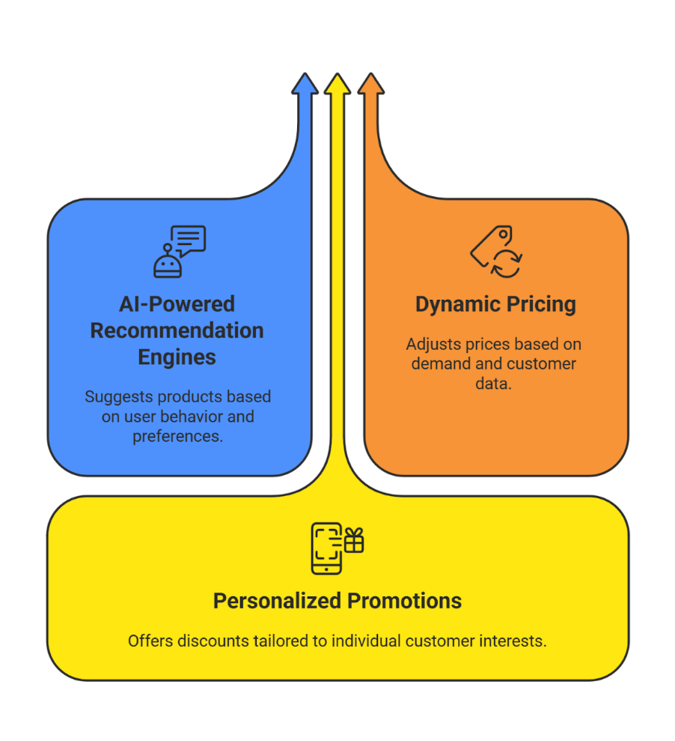
Enhancing In-Store Experiences Through AI
Smart Stores and Connected Retail Environments
The physical store remains a critical touchpoint in the customer journey, and AI is transforming these spaces into intelligent environments that blend the best aspects of digital and physical retail:

- Smart mirrors in fitting rooms display product information and recommend complementary items
- Digital price tags adjust in real-time based on demand and inventory levels
- IoT sensors track customer movement to optimize store layouts and reduce congestion
- Beacon technology delivers personalized promotions to customers' smartphones as they move through the store
These technologies create a more interactive and engaging in-store experience while providing retailers with valuable data about customer behavior and preferences.

Facial Recognition and Customer Identification
AI-powered facial recognition helps identify returning customers, deliver personalized and VIP experiences, and ensures privacy through data protection and opt-in policies. It also enables frictionless checkout via computer vision-powered cashierless stores, mobile scan-and-go solutions, biometric payments, and smart shopping carts. Additionally, AI-driven in-store analytics optimize operations in real time by monitoring queue lengths, mapping customer movement, tracking shelf stock, and improving staff allocation, resulting in a more efficient and seamless shopping experience.

Customer Experience Metric | Before AI Implementation | After AI Implementation | Improvement (%)
Response Time | 12-24 hours | Instant or <5 mins | 85% faster
Customer Satisfaction (CSAT) | 70% | 90% | 20% increase
Personalized Product Recommendations | Generic suggestions | AI-driven, tailored offers | 40% higher engagement
Shopping Cart Abandonment Rate | 75% | 50% | 25% decrease
Customer Retention Rate | 60% | 80% | 20% increase

Retail AI Success Stories
- Sephora: Virtual try-on, personalized recommendations, and adaptive in-store displays.
- Stitch Fix: Data-driven styling, predictive inventory management, and continuous feedback.
- Walmart: Shelf-scanning robots, intelligent forecasting, computer vision for security, and personalized e-commerce.
- Nike: AR shoe sizing, AI-powered product drops, subscription services, and unified customer profiles.

7.3 Discussion
AI is a transformative force in retail management. It reshapes customer service delivery while enhancing back-end operations, including supply chain, marketing, inventory management, and strategic planning. Successful adoption requires balancing automation with human empathy to maintain trust and maximize customer satisfaction. Retailers leveraging AI gain significant competitive advantages through personalization, operational efficiency, and seamless omnichannel experiences.

8. RECOMMENDATIONS & CONCLUSION
Recommendations:
Retailers should adopt a hybrid service model where AI manages routine tasks while human staff handles complex or sensitive issues, ensuring both efficiency and empathy. Employee training is essential so staff can collaborate effectively with AI systems and view them as tools for support rather than job threats. Transparency should be maintained by informing customers when they are interacting with AI, helping build trust and confidence. Strong data privacy and security policies are crucial to protect customer information and address ethical concerns. Additionally, retailers should continuously monitor and evaluate AI performance to ensure these systems operate effectively and align with customer expectations.
Conclusion:
AI-driven customer service is transforming retail by improving operational efficiency, enhancing customer experiences, and enabling data-driven decision-making. Although challenges related to privacy, transparency, and human–AI balance exist, the overall benefits are substantial. Retailers that implement AI thoughtfully and strategically will be better positioned to meet the rising expectations of modern consumers, strengthen customer relationships, and maintain a competitive advantage in an increasingly digital retail landscape.

9. BIBLIOGRAPHY & REFERENCES (APA 6th Edition)
Deloitte. (2023). AI in retail: Transforming customer experience. Deloitte Insights.
https://www2.deloitte.com/insights
Gartner. (2022). Artificial intelligence trends in global retail. Gartner Research.
https://www.gartner.com/en
Harvard Business Review. (2021). How AI is changing retail customer service.
https://hbr.org
KPMG. (2023). AI adoption in India’s retail industry. KPMG.
https://kpmg.com/in
McKinsey & Company. (2022). The future of personalization and AI in retail. McKinsey & Company.
https://www.mckinsey.com
Retail Week. (2021). Chatbots and customer service automation. Retail Week.
https://www.retail-week.com
Statista. (2023). AI usage in global retail businesses. Statista.
https://www.statista.com
TechCrunch. (2022). AI tools reshaping online retail experience. TechCrunch.
https://techcrunch.com

